**DAILY ONLINE ACTIVITIES SUMMARY**

|  |  |  |  |  |  |  |  |  |
| --- | --- | --- | --- | --- | --- | --- | --- | --- |
| **Date:** | **28 June 2020** | | | | | **Name:** | **K ISHA HEGDE** | |
| **Sem & Sec** | **4th sem, 2nd year** | | | | | **USN:** | **4al18cs031** | |
| **Online Test Summary** | | | | | | | | |
| **Subject** | | **-----** | | | | | | |
| **Max. Marks** | | **----** | | **Score** | | | **-----** | |
| **Certification Course Summary** | | | | | | | | |
| **Course** | **INTRODUCTION TO HADOOP** | | | | | | | |
| **Certificate Provider** | | | **GreatLearning** | | **Duration** | | | **3hours** |
| **Coding Challenges** | | | | | | | | |
| **Problem Statement:2 program** | | | | | | | | |
| **Status: Executed** | | | | | | | | |
| **Uploaded the report in Github** | | | | | **Yes** | | | |
| **If yes Repository name** | | | | | [**https://github.com/iishaii/cpp-assignment**](https://github.com/iishaii/cpp-assignment) | | | |
| **Uploaded the report in slack** | | | | | **Yes** | | | |

#### *Certification Course Summary:*

Today I started new course INTRODUCTION TO HADOOP in Great Learning which is of 8 hrs. After the completion of course, certificate will be provided.

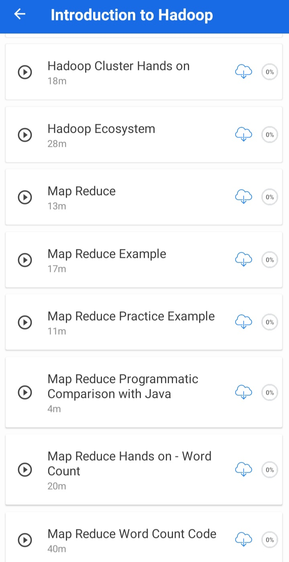

***Coding Challenges:***

Today I solved 2 coding challenge,

1. **Write a C++ program to find the sum of 2 integers using Pointers**

**2. Write a C++ program to enter the details of students and display them using class and object. The details should be private in nature and use public members function to access the private members. (Define the member function outside the class).**

I HAVE UPLOADED THE SOLUTION IN MY GITHUB REPOSITORY.

<https://github.com/iishaii/cpp-assignment>

